**ASSIGNMENT 2**

Subash A L

AC19UCS116

Tittle:

Pharma Sales Dashboard

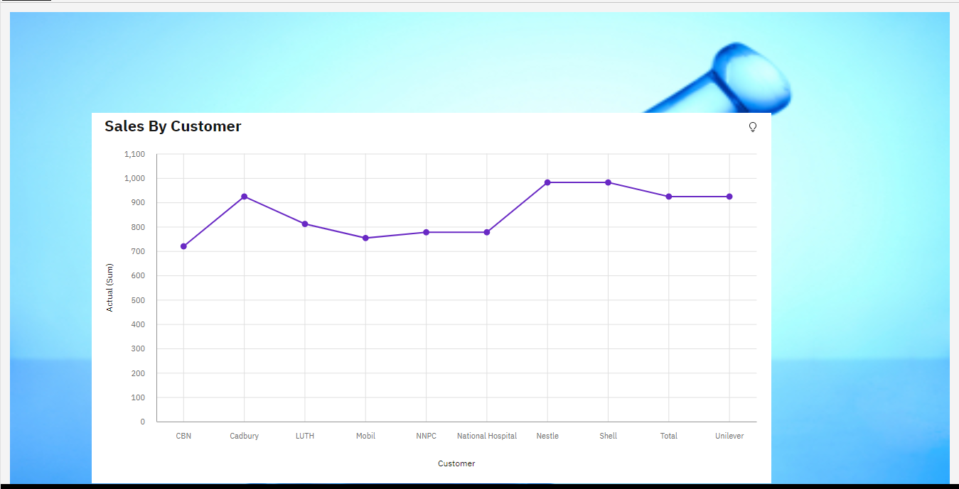Task 1:Sales By Customer.

Task 2:Sales By Location.

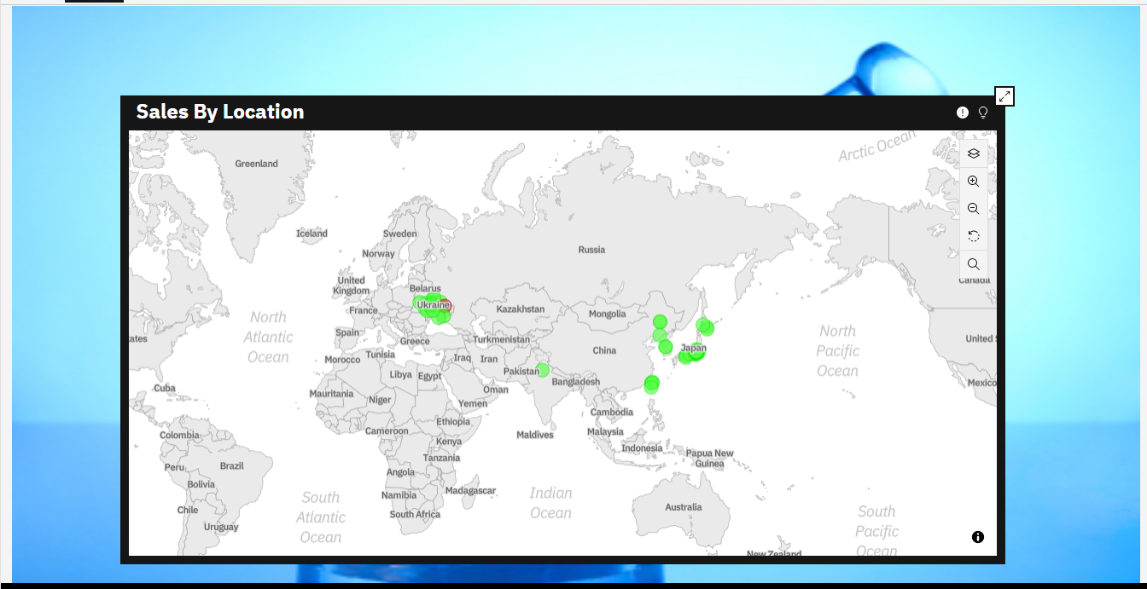

Task 3:Sales By Sales Representative.

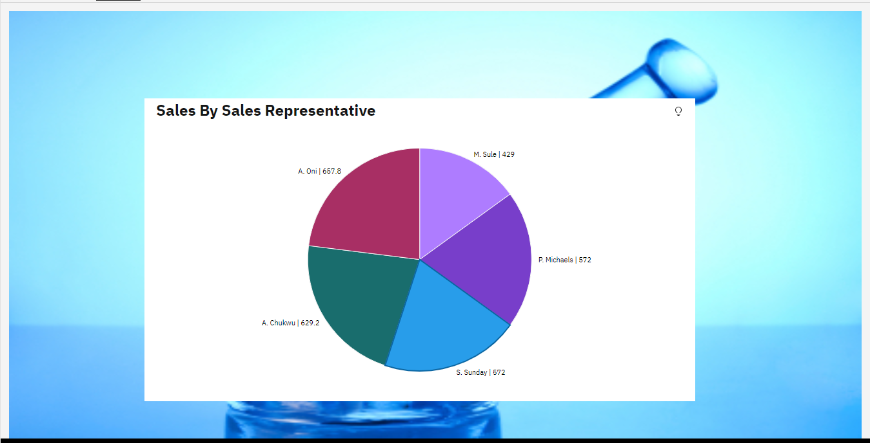

Task 4: Received Inventory From Supplier

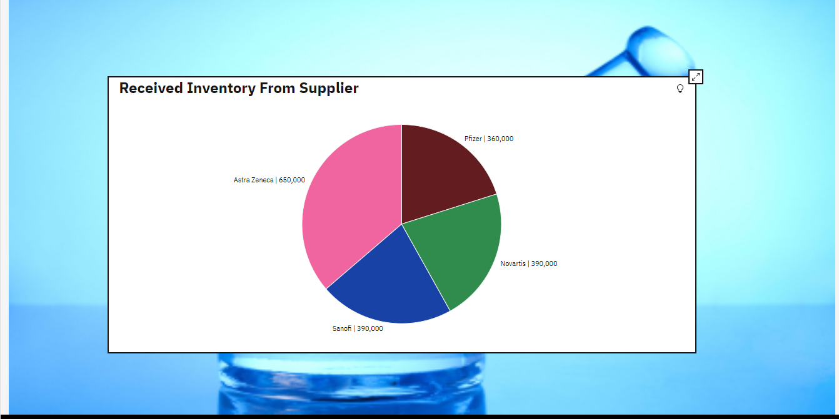

Task 5: Inventory Stock for Warehouse Locations

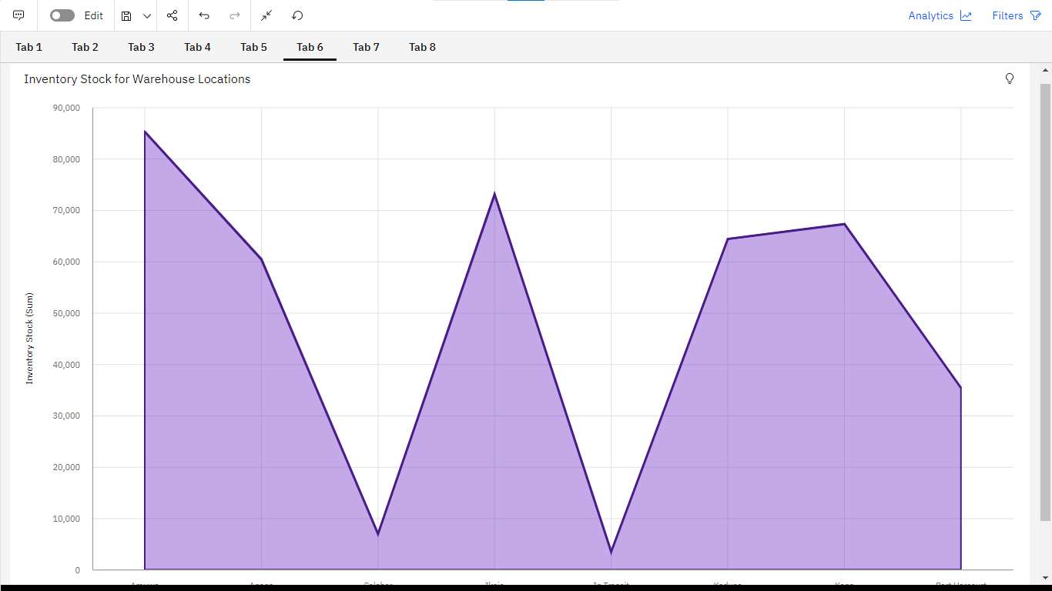

Task 6: Sales Trend

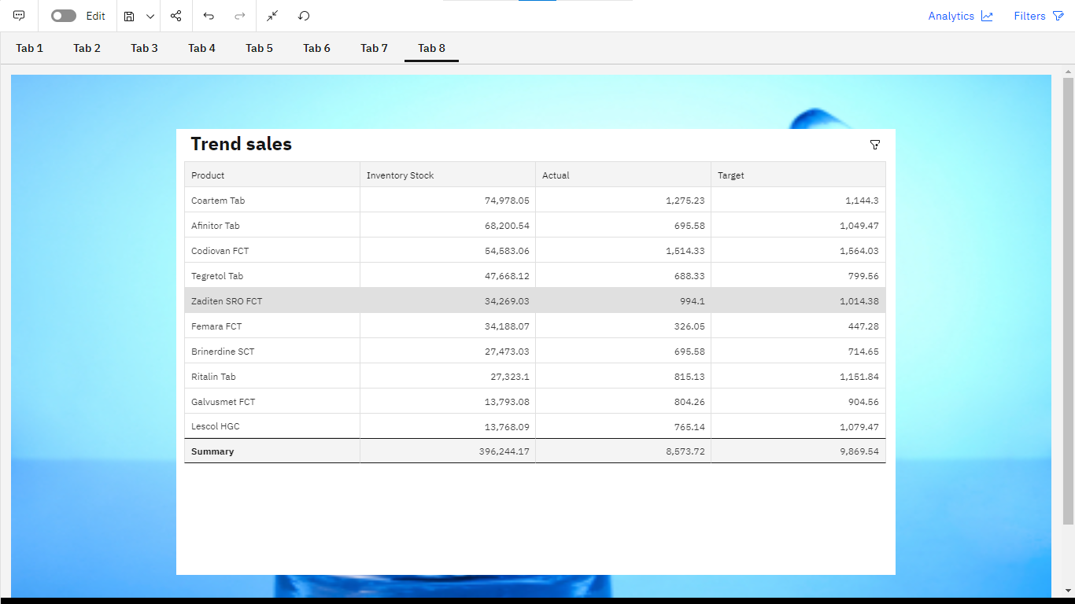

Task 7:Monthly Sales

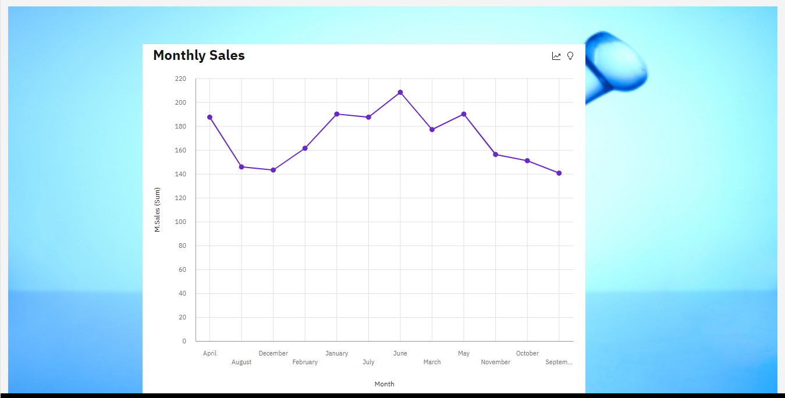

Task 8: Actual and Received Inventory by Month

